**Brooklyn torah gazette**

**For parshas metzora 5782**

Volume 6, Issue 29 (Whole Number 284) 8 Nissan 5782/ April 9, 2022

**The Saga of Robyn (a**

**Reform Rabbi) Frisch &**

**Her Orthodox Son Benji**

**By Daniel Keren**

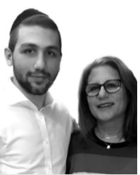

**Robyn & Benji Frisch**

Hope your Pesach preparations are going smooth with just another week before our long-awaited festival of freedom. May we still have the zechus (merit) to celebrate it this year in Yerushalayim with Moshiach Tzidkeinu and the real Pesach korban (sacrifice) for the afikomen.

You might remember my recent column (“A Granddaughter Recalls the Mensch of Malden Mills” – 02/25/22) in which I discussed a January 5th podcast from Dovid Bashevkin’s 18.Forty.org. I have become a subscriber since then to the website and on March 15th, I got another very fascinating one hour and thirty-minute podcast titled – **“Robyn Frisch & Benji Frisch – A Child Becomes Orthodox.”**

Whatever side of the Jewish community you hail from, whether haredi, modern Orthodox or secular/assimilated, you will find this podcast of 18.Forty.org fascinating. Especially if you are a bail teshuva, you will gain insights as to what your spiritual decision meant to your loving parents. And if you are from a frum from birth family, Bolshevik’s podcast will give you precious insights into the challenges that secular families and their baalei teshuva relatives undergo when a family member becomes Orthodox.

Bashevkin who is currently the director or education for NCSY, the youth movement of the Orthodox Union and an instructor at Yeshiva University, in his podcast talks to both Rabbi Robyn and her son Benji exploring their efforts to not let a son’s growing interest in Yiddishkeit (Judaism) divide their family. Even if your family doesn’t have a theological split, you might find the efforts of all the members of the Frisch to get along with each other as explained to Bashevkin very valuable.

Bashevkin discovered the Frisch saga when he came across an article that Robyn Frisch wrote last year (March 15, 2021) in The Forward titled “**Reform, Conservative, Haredi** **— It’s All in the Family.”**

In that amazing article Robyn writes:

“I’m a Reform rabbi, my husband Seth is a Conservative rabbi, and one day our son Benji will probably be a haredi rabbi.”

In both the Bashevkin podcast and in Robyn Frisch’s article in the Forward, one can sense the beautiful power of a family that wants to keep shalom bayis.

******************************************************************

Thousands of hespedim (eulogies) have been delivered over the past two weeks by rabbis and Torah scholars around the world in the aftermath of the petirah (death) of the Sar HaTorah, our generation’s most outstanding and distinguished Talmid Chacham (Torah scholar) – Rav Chaim Kanievsky, zt”l. And many if not most have been posted on various websites.

Two hespedim that I recommend are from two American expatriate rabbis who teach at the Ohr Somayach, a yeshiva in Yerushalayim for English-speaking young men who come from secular assimilated backgrounds. Both hespedim can be found on the Torahanytime.com website.

By googling **The Passing of a Gadol – Rav Chaim Kanievsky** – you can listen to an insightful 52-minute eulogy by Rabbi Dovid Gottlieb, a senior faculty member at Ohr Somayach in Jerusalem. An author and lecturer, Rabbi Gottlieb received his Ph.D. in mathematical logic at Brandeis University and later become Associate Professor of Philosophy at Johns Hopkins University, before making Aliyah to Eretz Yisroel where he joined the faculty of Ohr Somayach.

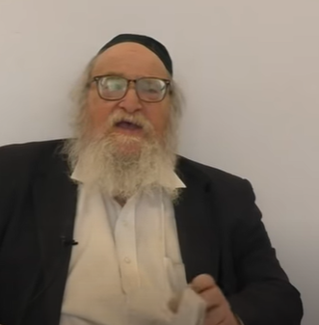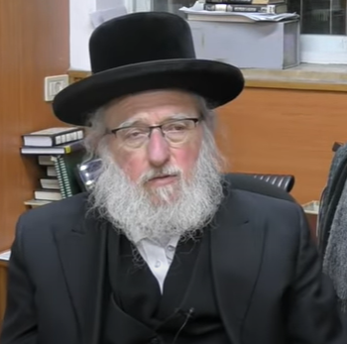

**Rabbi Yitzchak Breitowitz Rabbi Dovid Gottlieb**

To watch or listen to Rabbi Breitowitz’s eulogy on our nation’s great spiritual loss you can google **Remembering Rav Chaim Kanievsky – Rabbi Yitzchak Breitowitz**. Rabbi Breitowitz gained his rabbinical ordination from the Ner Israel Rabbinical College in Baltimore and at the same time earned a bachelor of arts degree from John Hopkins University also in Baltimore. Before making Aliyah to Eretz Yisroel, Rabbi Breitowitz who also graduated from Harvard Law School magna cum laude served as the Rav of the Woodside Synagogue in Silver Spring, Maryland and served on the faculty of the University of Maryland School of Law in Baltimore.

Rabbi Breitowitz told the story that has been well recorded in articles and lectures of when Rav Chaim Kanievsky was writing a sefer (book) that discussed the question of which locusts (chagovim) are kosher. Ashkenazim don’t eat chagovim because we don’t know the mesorah (tradition) of which locusts are kosher from the Chumash (Bible) and permitted. Many Sephardim (from Yemen and North Africa) believe they know the mesorah and they do eat chagovim. I understand that they are best eaten roasted.

Rav Chaim was frustrated by his inability to personally view chagovim up close. One day, from out of nowhere, a locust popped up onto his kitchen table and he quickly examined it and was able to complete his sefer on that discussion of the chagovim. Apparently one rabbi who heard of this story, remarked that he didn’t believe that G-d would help Rav Chaim in such a remarkable manner.

Rabbi Breitowitz explained that all of a sudden that doubting rabbi’s house was inundated with an invasion of locusts. No manner how many times the exterminator came, the chagovim continued to invade the rabbi’s house. Someone suggested that the poor man go to Rav Chaim and beg for his mechilah (forgiveness) for doubting that Hashem would help him in his research project. He did and Rav Chaim did indeed forgive him. And sure enough, the problem of locusts disappeared from the home of the doubting rabbi.

*Reprinted from this week’s issue of the Jewish Connection.*

**Rav Avigdor Miller on**

**When Hashem is Not Silent**



**QUESTION:** **When we see how the present government in Israel has appointed a Minister of Religions and a Minister of Education who are so anti-religious and they’re doing other things against frum Jews in Eretz Yisroel, trying to wipe out every vestige of Torah, could it be that Hashem will remain silent?**

**ANSWER:** Could we think Hakodosh Boruch Hu will be silent when He sees that the reshaim are trying to wipe out the Torah in the Eretz Yisroel?

The answer is, He’s not silent.  That’s why there are terrorists.  It’s a big mistake to read the newspapers and think that it’s the result of them not wanting the peace treaty or because they want to have the Jews out of Eretz Yisroel.  No.  The terrorists are sent by Hakodosh Boruch Hu as a puraniyos on the Labor Party, on the apikorsim, on those who are trying to teach Jewish children immorality and atheism in the Israeli public schools.

Now, don’t misunderstand me – I’m not sympathizing with the Arabs. The Arabs are reshaim gemurim. But absolutely that’s why the terrorists come.  No question, Hakodosh Boruch Hu is punishing the people in Eretz Yisroel.

Of course, when troubles comes because of the koitzim, because of the thorns, so the gemara says that the gadish, the good crop, is also affected.  ונאכל גדיש או קוצים – just because of the thorns, the good ones also suffer to some extent (Bava Kama 60a). And it says there that sometimes the troubles come onto the better ones first. Even tzadikim suffer because of the reshaim. But there’s no question, we should never forget that any act of terror against the people in Eretz Yisroel is nothing but the result of the sins of the Jews in Eretz Yisroel.  Don’t make any mistake about it.

*Reprinted from the March 30, 2022 email of Toras Avigdor. Adapted from Tape #E-31 (October 1996)*

**Rabbi Berel Wein**

**On Parshas Metzora**

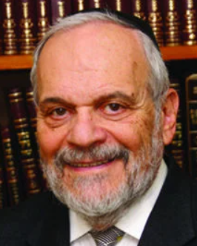

This week's Torah portion remains one of the most mysterious and supernatural demonstrations of the laws of Judaism, which appears anywhere else in the holy books. We are not aware of the specific nature of the disease that is described. Leprosy is certainly not the correct translation or identification of this disease called *Tzoraat* in the Torah. The cause for the disease, however, is alluded to in Jewish tradition. It apparently stems from the violation of the prohibition against evil speech.

This can be deduced from the fact that one of the miracles that our teacher Moshe was bidden to perform to validate his mission in front of Pharaoh and the Jewish people was to insert his hand into his breast clothing and remove it. That hand turned white with the same disease described in our Parsha as *Tzoraat*. When he reinserted his hand and then removed it, it returned to its normal strength in color. We also find that Miriam when she was punished for speaking ill against Moshe was stricken with this disease.

In these instances, the Torah makes clear to us that evil speech – Moshe speaking against the Jewish people and saying that they will not believe him, and are unworthy of redemption, and Miriam speaking ill of her brother -- criticizing his handling of his personal domestic life – suffered the punishment of this disease striking them. As such, it became evident in Jewish scholarship that there was a connection between this disease and between speaking ill of others. Nevertheless, this does not explain the nature of this disease, and why it was chosen as being the instrument of punishment and retribution for the sin of evil speech.

We find in the book of Kings and in the works of some of the prophets that this disease struck some of the leaders and kings of Israel during later times as well. The rabbis of the Talmud compared the appearance of *Tzoraat* on the skin of King Uziyahu of Judah as being comparable to an earthquake. Apparently, this disease, more than any other physical ailment, was meant to shake up the society and to instill within it proper respect for the word of God and the value system of the Torah.

Since we are unable to identify the disease, it is not part of our daily or even spiritual view of events. The only lesson left to derive from these descriptions of the disease, then, is that heaven is indeed conscious of our thoughts, actions, speech, and behavior. And that these have consequences both for the good and for the better. We also see from the Torah that the expert on this type of event was the Priest-Kohen, and not the medical doctor, or even the wise scholar of the time.

The Kohen was thought to be the prime connection between the judgment of heaven and the behavior of humans. It was, therefore, the High Priest alone who could bring atonement for the Jewish people on the day of Yom Kippur. Spiritual disease comes from spiritual failing, and, therefore, requires the healing effect of spiritual greatness which was bestowed upon the family of Aaron and the Jewish priesthood.

*Reprinted from this week’s website of rabbiwein.com*

**Parshas Metzorah**

**The Holiness of the Jews**

**By Rabbi Ben Tzion Shafier**

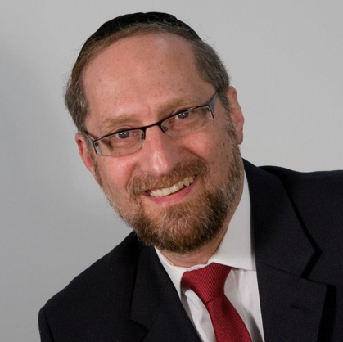

As Jews, we are commanded to be a holy nation. To help maintain our spiritual level, the Torah provides safeguards to protect us from sin. One of these is Tzaraas. In the time of the Bais Ha’Mikdash, (which should speedily be rebuilt), if a person spoke Loshon Harah, he contracted Tzaraas. While the outer manifestation was a type of skin condition, a Metzorah had entered a stage of Tumah, which forced him to be removed from normal life. Anything that he then came into contact with became Tameh, and he had to leave the encampment of the Jews and remain separated from the rest of the nation until he was purified.

**The Metzorah Becomes Purified**

To become purified from this state, a Metzorah had to go through a complex, three-part process. After the Kohain looked at his neggah and saw that it had healed, the first part began. The Kohain was commanded to take two live, kosher birds, a piece of cedar wood, and hyssop (a branch from a particular bush), and then tie them together with a string of purple wool, and dip them all into the blood from the first bird.

Rashi explains that each of these was part of the Kaparah, a correction and atonement for his sin. The cedar wood, which comes from a tall, strong tree, was to signify that his speaking Lashon Harah was caused by arrogance. The purple-dyed wool and hyssop come from lowly sources, and serve as a message to the Metzorah that he should lower himself. And the reason that for the kosher birds are that birds are constantly chirping, and Loshon Harah is an act of chirping.

**Human Speech Cannot be**

**Compared to Birds Chirping**

This Rashi seems difficult to understand. The chirping of the birds doesn’t seem to fit into the equation. If you listen to the sounds of birds chirping on a spring day, you’ll hear an unending stream of sound, much like turning on the faucet in your kitchen sink. The flow begins, short chirps and long chirps forming some type of pattern, but it’s without thought; the birds just jabber away.

What connection does that have with intelligent speech? Speech isn’t merely the formation of sounds; speech is the highest form of communication, a power given to man alone to share his inner thoughts and understandings. Each word or phrase can represent entire concepts and ideas. Man alone can relay a world of understanding in but a few expressions. In what way can that be compared to the chattering of birds, a mindless, thoughtless, automatic reflex?

**There is No Instinctive Urge to**

**Speak Despairingly About People**

The answer to this question is based on understanding how Loshon Harah comes about. The Chofetz Chaim points out that one of the prohibitions that a person violates by speaking Loshon Harah is Chillul HASHEM. He explains that if someone has a powerful desire to commit a sin and then transgresses it, it may be a serious offence, but there is a mitigating factor – he fought a battle and lost. Loshon Harah, on the other hand, is very different.

There is no driving, instinctive force that pulls us to speak disparagingly about other Jews. There is no magnetic pull that tugs at us. Therefore, if a person speaks Loshon Harah, it can be a Chillul HASHEM; since he is committing this sin without any powerful desire, it must be that he utterly disregards the command of the King.

Loshon Harah usually is mere chatter, much like the chirping of a bird

What we see from this is that much of Loshon Harah isn’t purposeful, malicious speech. In fact, it is rare that we engage in intentionally divulging great secrets with the specific intention of ruining another person’s reputation or business. Rather, in the course of conversation, we sort of prattle on. “Hey, did you hear? I don’t know if you know this, but…” Most often, it is simple drivel. Without much forethought, and certainly without regard to the consequences of the sounds that are emanating from the openings in front of our faces, we fill the empty space with chatter.

In that sense, the bird is the perfect atonement. Since Loshon Harah comes about through prattle, the Torah commands the Metzorah to bring a bird as the atonement for what allowed him to come to this sin.

**Preventing Loshon Harah**

This concept has great application in our lives. There are rare occasions when we speak out of malice and desire to avenge a perceived wrong, and in those cases it is difficult to stop ourselves from speaking Loshon Harah. However, the vast majority of Loshon Harah that we engage in is senseless gossip – prattling like chirping of a bird. So while it is common place, it is much easier to work on eradicating it. By simply being aware of ourselves and by learning the halachos of Shmiras HaLashon, we can easily prevent much of the damage of our spoken words. As we become conscious of what flows out of our mouths, we stop the mindless prattle that does so much damage to others.

*Reprinted from the website of TheShmuz.com*

**Amazing Lesson from Brisker Bochur Who Went to a Non-Jew’s Hotel Room to Discuss Football**

At a schmooze recently at a Mesivta in Bnei Brak, Rabbi Yehuda Aryeh Dunner told a fascinating story about an American bochur attending Rav Dovid’s Brisk. Rav Dunner said, “The bochur was visiting the Kosel, and saw an American goy writing a kvittel and placing it into a crack.

“The bochur was curious about what the goy could possibly have written. After the goy left, the bochur pulled out the note and read the English message: “For the sake of G-d, there is a football game right now between team X and team Y in America, please let me know who won. Thank you, Alex.”

“The goy went so far as to write his room number at the Plaza Hotel beneath his signature on the kvittel. The bochur decided to answer the man’s prayer. He called his father in the U.S. and asked him who won the game. The father was taken aback.:

‘You’re learning in Brisk. What does this have to do with Zevachim and Menachos? The bochur said that he would explain later, and again asked for the score. The father checked the results of the game and told his son. The bochur took a taxi to the hotel, went to the goy’s room, knocked and asked:

“Are you Alex’? The goy said yes. The young man replied: ‘I am a messenger of G-d. The goy was annoyed and asked, “What do you want, messenger of G-d?” The bochur replied, “You asked G-d who won the football game.” The goy was startled.



“The bochur then said: ‘G-d sent me to tell you that team X won. The goy got excited and thanked the bochur emphatically. Then he pulled out a checkbook and wrote him a check for $2,000, saying “This is for the Messenger of G-d.”

“The bochur returned to yeshiva, and his friends began debating whether he was allowed to keep the money. They said, “You lied about it, and also it was a gift from a goy.”

The bochur replied: ‘If I were to tell him that Hashem asked for $2,000 it would certainly be forbidden, but here the goy gave it on his own.” Rav Dunner said that they called to ask his opinion, and he paskened that he was allowed to keep it. However, the story does not end there. Rav Dunner continued: “When the bochurim were discussing the shaila in Bais Medrash, the Rosh Yeshiva, Rabbi Dovid Soloveitchik (zt”l) saw them arguing, and asked what they were discussing. “And here we see how a Gadol looked at the story. Rav Dovid said ,’A goy just asked Hashem for something, and Hashem answered him.’

Rav Dunner continued: “Now we see a new picture of this story. Who gave this guy a bug in his head to open the note, and travel all the way to see the goy? It’s all from Hashem. “This means that the goy asked Hashem to tell him who won the game – and Hashem answered him.”

Why Hashem answered him is not relevant, the lesson for us is that we see that even when a goy simply asks, he gets an answer, all the more so when a Jew asks Hashem, ‘I want to understand the Gemara, I want to understand the Chumash. He will answer, He has no shortage of ways and it has nothing to do with us – and this is the lesson for us, and this is what a yeshiva guy needs to know. ”

Rabbi Dunner concluded the schmooze by saying that every yeshiva bochur should recognize the power of tefillah, and should ask Hashem to help him understand his learning, and ask for answers in areas where he is striving to succeed. (VINnews 1/19/22)

*Reprinted from the Parshat Metzorah 5782 email of R’ Yedidya Hirtenfeld’s whY I Matter, the parsha sheet of the Young Israel of Midwood in Brooklyn.*

**Two Ukrainians Discover They’re Sisters while Fleeing to Israel**

**By**[**Dr. Yvette Alt Miller**](https://aish.com/authors/84110707?aut_id=4960)

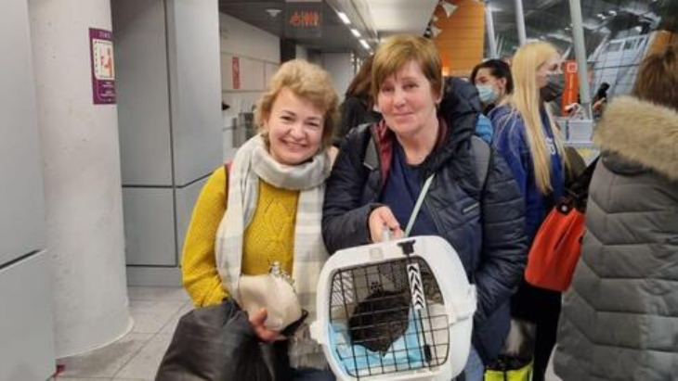

***Valentina and Mariana Varshavky discover they have the same father on their way to Israel.***

Since Russia launched its brutal invasion of Ukraine last month, over three million desperate Ukrainians have fled their country; more than 12,000 Ukrainians have found refuge in Israel. Last week, two women who joined this exodus made a startling discovery on the way.

*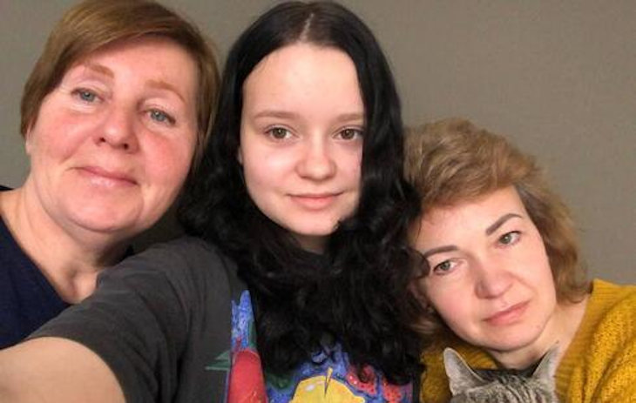****Valentina, right, her daughter Masha, center, and Mariana***

Valentina Varshavky and Mariana Varshavky have many things in common: they were both born in Kyiv; both are Jewish, and they share the same last name. Valentina and Marina each have a child who felt a strong pull to live in Israel and who moved to the Jewish state. As rockets rained down on Kyiv, both Valentina and Mariana fled their besieged city on the very same day, finding refuge in Poland, where they each made plans to go to Israel to join their children and rebuild their shattered lives.

Mariana Varshavky is a 53-year-old psychologist. Her parents divorced when she was young. After her father remarried, he lost touch with Mariana and her mother. Mariana’s son Pavel, now 26, always dreamed of living in Israel and moved there in 2018. He lives in Ramat Gan.

Valentina Varshavky, 46, worked as a banker in Kyiv until last month. She and her husband have two children: 13-year-old Masha, and an older son, Nikita, 23, who moved to Israel when he was 17 years old and lives in Haifa.

With a 40-mile-long convoy of Russian troops racing towards Kyiv in the early stages of the war, Mariana and Valentina knew they had to flee. (In recent days, Kyiv has come under heavy bombardment.) The two women made it over the border into Poland, where they each contacted the Jewish Agency, asking for help in moving to Israel. Mariana and Valentina, and Valentina’s daughter Masha, waited day after tense day in a Warsaw hotel, hoping for the moment when they could board a flight to the Jewish state.

**Shock of Discovering that**

**They Had the Same Father**

A week and a half ago, they were finally cleared to go. They listened as a Jewish Agency employee read off their names and the names of 150 other Ukrainian refugees who were on their same flight to Israel. Mariana and Valentina heard their last name Varshavky being called and struck up a conversation, marveling at the coincidence of having the same surname. They soon realized with a shock that they had the same father.

“I didn’t even know that I had another sister,” Valentina told reporters after making her startling discovery. “The most amazing thing is that amid all this chaos we found one another,” explained Mariana. “We thank the Jewish Agency, and we thank Israel and love Israel even more after our reunion in Warsaw. We got on the plane together, like one big family, and we’ll arrive in Israel. There we’ll introduce our sons to each other. What joy, what a miracle.”

**Jewish Agency Trying to Help**

**Tens of Thousands of Refugees**

On the day that Mariana and Valentina landed, March 9, 2022, they joined hundreds of other new immigrants to the Jewish state, hailing not only from Ukraine but also from Russia. “I never imagined I would end up doing what I am doing today. I’ve seen things I never thought I would see in my life, it’s like World War II, people sitting in lines for two days,” explained Shmuel Shpack, the Ukraine director for the Jewish Agency of Israel. In the face of overwhelming need, the Jewish Agency for Israel is doing all it can to help the tens of thousands of refugees who are clamoring to reach the Jewish state.

These refugees face daunting obstacles as they rebuild their lives. They need to learn a new language, find new jobs, and make new friends.

For Mariana and Valentina Varshavky and their families, creating new lives in Israel will be made much sweeter by knowing that they are doing it together with their newly discovered family.

*Reprinted from this week’s website of Aish.com*